Simulation Results :

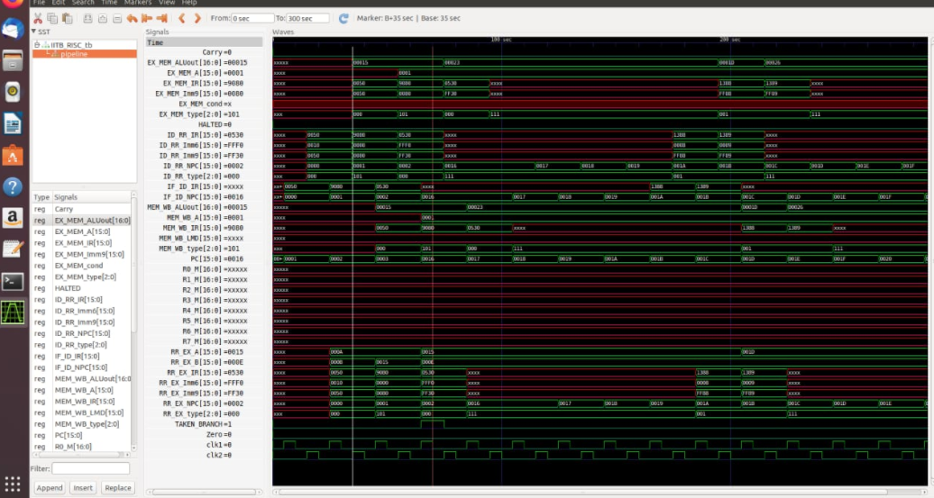

Data Flow chart of the 6 stage RISC Processor :

